**Project – Student Portal**

* **Summary of project**
* The scope of this website where student can register and can login and this website is designed in core PHP. Automation test case is all about automating this functionalities and idea is to create all the process with the help of Cypress.
* **Project Screenshots**
* **Login page**

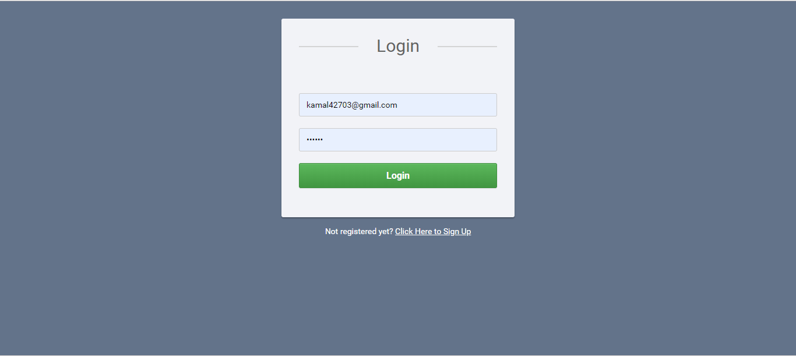

* **Registration**

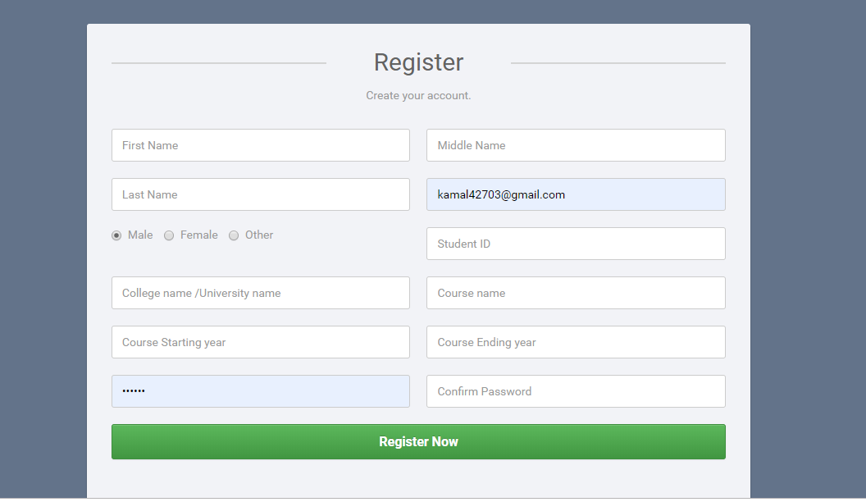

* **Logged in**

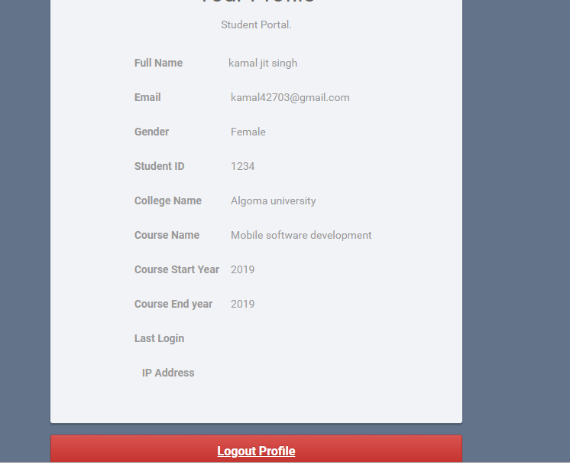

* **Test cases**
* **Registration**

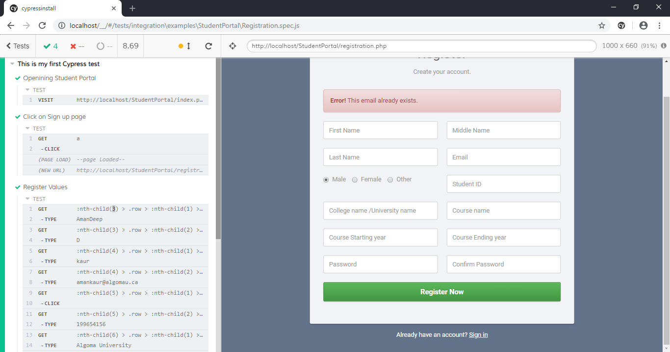

* **Sign Up – Passed**

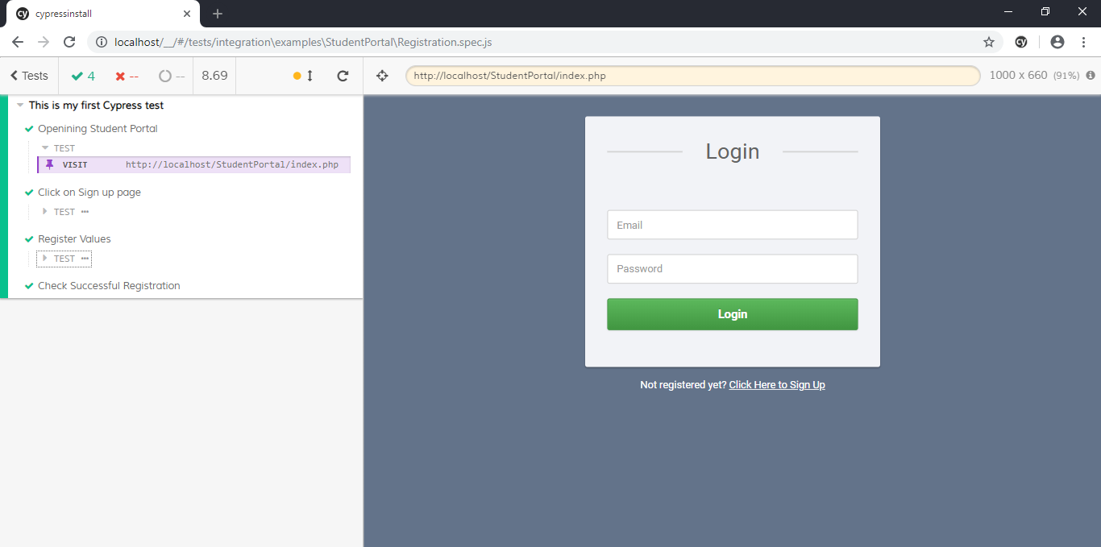

* **Put same credentials- Failed**

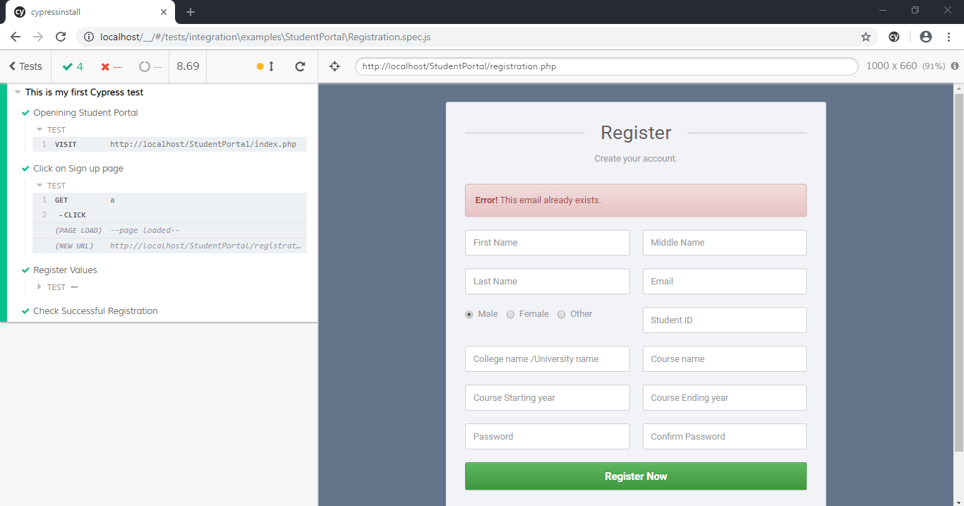

* **Check Login validations**

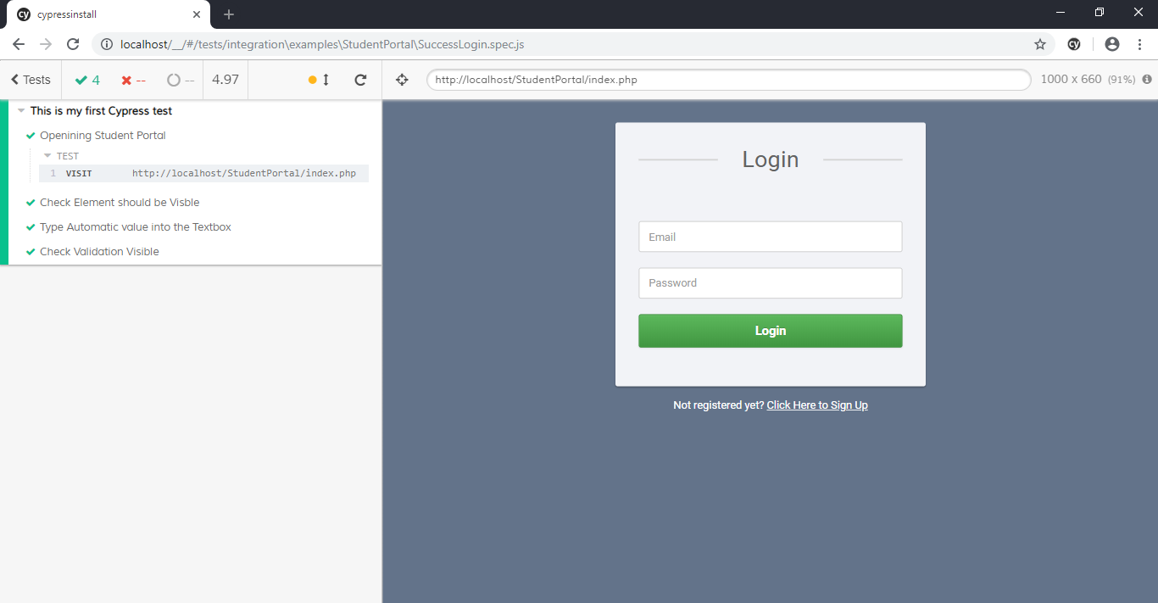

* **Pipeline**

A job is not created because Jenkins server is not available.

The github URL of live project

<https://github.com/amankaur01/StudentPortalProject.git>